**Portfolio**

**ENGKISH WRITING SKILLS AND COMMUNICATIONS**

**Semester: 2nd**



**Prepared and Submitted by:**

Name: Nokibul Arfin Siam.

ID: 21-44793-1.

Section: G.

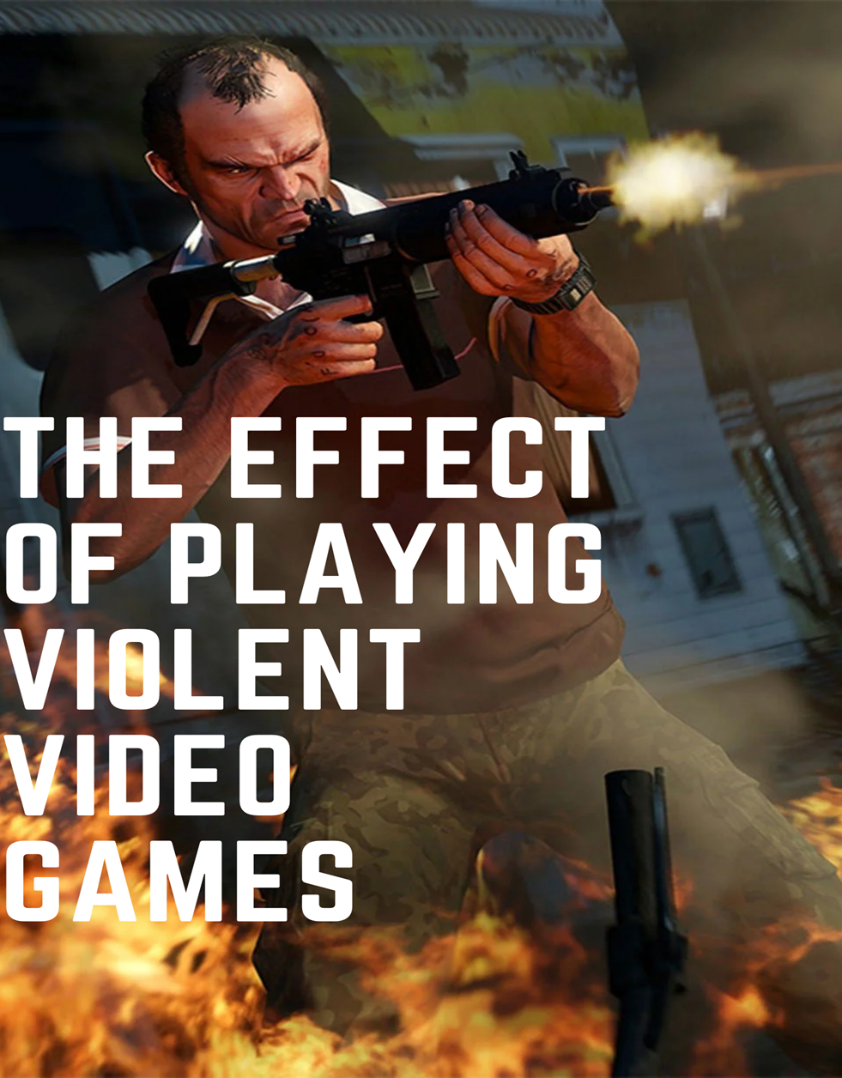

**Table of Content**

|  |  |  |  |  |
| --- | --- | --- | --- | --- |
| ***Sl*** | ***Task Title*** | ***Deadline for***  ***Submission*** | ***Date of***  ***Submission*** | ***Page No*** |
| 1 | Develop specific & focused topic on a given theme and Brainstorm on focused topic | June 19, 2021 | Sat Jun 19 | 4 |
| 2 | Collect at 3 relevant articles and  Take Notes | June 19, 2021 | Sat Jun 19 | 4-7 |
| 3 | Write the revised and completed Outline of the essay | June 22, 2021 | Mon Jun 21 | 8 |
| 4 | Write Introduction with Thesis  Statement | June 22, 2021 | Mon Jun 21 | 9 |
| 5 | Write three body paragraphs and Conclusion by using sources | June 29, 2021 | Mon Jun 28 | 9-11 |

**Essay Title: The effects of playing violent video games.**

1. **Brainstorming (Generating ideas):**

Some important prewriting techniques for gathering ideas are**- Brainstorming, Outlining and Mind mapping.**

**Brainstorming (Generating Ideas for Essay)**

Desensitization to aggression

Increase aggressive personality

Sadness despair

effects of playing violent video games

Decrease concentration in studies

**Causes of**

Decreased social skills

Relationship troubles

Excessive phone addiction

Insomnia

# **Collecting materials:**

# Resource mat 1: www.center4research.org/violent-video-games-can-increase-aggression

Studies have shown that playing violent video games can increase aggressive thinking, behavior and feelings, both in the short-term and long-term. Violent video games encourage people from viewing aggressive behavior and reducing professional behaviors such as helping another person and feeling empathy (undertesting others. The longer people are exposed to violent video games, the more aggressive behavior, thoughts and feelings they have. These effects have been seen in both Eastern and Western countries. Moreover, males spend more time than females playing violent video games, violent video game exposure can increase aggressive thoughts, behaviors, and feelings in both sexes. Some studies look at self-reporting of injury or pushing, and some look at peer or teacher ratings on aggressive behavior. Other studies have shown how likely a person is to suffer unpleasant exposure to hot sauce or loud noises after playing violent video games. Unfortunately, a few studies on violent video game exposure and aggression in children under 10 have been completed. There is also little information about the impact of violent video game exposure on minority children. There has not been much research on the effects of different features of video games, such as perspectives or plots. Still, some studies have shown that competition among players in video games is a better predictor of aggressive behavior than levels of violence.

**Notes:**

* Playing violent video games can increases aggressive behavior.
* Violent video games cause excessive phone addiction.
* Playing violent video games also decreased the concentration of the studies.
* Males spend more time than females playing violent video games.

Resource mat 2: www.ukessays.com/essays/young-people/negative-effects-of-video-games-on-teenagers-5738.php

The world has changed and evolved rapidly in the past few decades. The invention of computer and modern internet has changed the fundamental needs of the teenagers. Video games on consoles, computers and smartphones have revolutionized the world and the concept of virtual reality. Many teenagers find it playing video games interesting especially violent video games.  This is due to how entertaining and thrilling they are to them as teenagers. However, playing video in most cases has some negative effects to the player. Violent video games sometime make an individual’s brain a lot of awake to violence. Unconsciously, such type of video games leads to aggressive increase in behavior and as time goes on, the brain doesn’t understand that aggression to be anything abnormal. Addiction to video games hinders the physical health of a teenager. Excessive sitting while playing video games may causes physical health problems such as obesity, back pains, insomnia, and drowsiness. A common health problem that most people face, especially teenagers addicted to playing violent video games, are obese. Addicted gamers usually face this problem because they are prone to sitting in one place for a long time, and as a result their body virtually misses any kind of physical activity like exercise. There have been mental health issues in playing video games for incredibly long periods of time which also negatively affect the social behavior of the teenager. According to a research conducted by Douglas Gentile released by the Iowa State University utters that, “teenagers are most inclined to video games by being indoors, which leads to a bad habit of socialization.” Therefore, excess video- gaming can lead to psychological impact on an individual, precisely teenagers.

**Notes:**

* Violent video games often make an individual’s brain more responsive to violence.
* Addiction to video games hinders the physical health of a teenager.
* Playing violent video games causes psychological health issues.
* Playing violent video games decreased social skill of the teenagers.

Resource mat 3: http://honors.usf.edu/documents/Thesis/U48383340.pdf

Video games became exponentially popular over the past few decades. As a result, they have become a societal staple, research has explored possible ways in which video games could affect one’s health. Specifically, video games may impact sleep, leading to poor sleep. Because of this, sleep deprivation is a vital area of concern. Research has found that sleep deprivation can affect a person psychologically, also it may also affect a person physically. Sleep quality is a characteristic of insomnia that may lead a person to have trouble falling asleep or staying asleep. In addition to sleep quality, violent video games can also have an effect on physiological arousal. Studies have shown that taking part of violent video games can**increase aggressive thoughts, behaviors, and feelings**in both the short and long-term. Violent video games can even desensitize individuals to seeing aggressive behavior and reduce prosocial behaviors like helping another person and feeling empathy (the ability to understand others). The addictive nature of video games will perform real-life violence also. People who classify themselves as a regular gamer (at least 30 hours per week) face a higher risk of social isolation because of their gaming habits. Some players like better to isolate from the real-world or put aside personal responsibilities so that they can continue to play. About 1 in 10 gamers face the struggles of addiction on a daily basis because of their need to get back into their preferred gaming world. Video games were very popular. Generation after generation video games has developed, but unfortunately after all that development it starts to become worst. This implies that when children are exposed to violence, they become accustomed it and may grow up thinking violence is the norm. For example, when children are shown a violent clip for the first time, they react with a lot of anxiety however a second such or worse clip doesn’t have the same effect as a result they have become immune to violence. This can be dangerous because it lowers the children’s responsiveness to real violence.

**Notes**:

* Playing violent video game causes insomnia.
* A full-time gamer (at least 30 hours per week) face a higher risk of social isolation because of their gaming habits.
* Violent video game may also affect psychological arousal.
* Playing violent video game is dangerous because it lowers the children’s responsiveness to real violence.

**The effects of playing violent video games**

**Essay Outline**

1. **I. INTRODUCTION**
2. **II. BODY**
   1. **A. Body/ supporting Paragraph 1**

**Main Idea: Decrease concentration in studies.**

**Supporting Ideas -**

1. Increase phone addiction
2. Reduce memorizing power
3. Give less time in studies
   1. **B. Body/ supporting Paragraph 2**

**Main Idea: Insomnia and increase aggressive personality.**

**Supporting Ideas –**

1. Hinders the physical health
2. Loss of mental stability
3. Bad behavior
4. give less time in sleeping
   1. **C. Body/ supporting Paragraph 3**

**Main Idea:**  **Isolated from the society and decrease social skills**

**Supporting Ideas –**

1. poor discipline
2. poor bonding in the family
3. instability in relationships with friends and family
4. affect psychological arousal

**III. CONCLUSION**

**The effects of playing violent video games**

The world has changed and evolved rapidly in the past few years. The invention of computer and modern internet has changed the fundamental needs of most teenagers. Video games on consoles, computers and smartphones have revolutionized the world and the concept of virtual reality. Many teenagers find it playing video games interesting especially violent video games. However, playing video in most cases has some negative effects to the player. Within the United States, citizens of all ages have either played video games or know someone who has played them. According to the Entertainment Software Association (ESA), 155 million people in the United States play video games. **The impact of playing violent video games on the manifestation of aggressive behaviors in young people is controversial. It also effects the psychological mind of the gamers. For this reason, they became isolated from their family and their society and also**  **decreases their social skills. It effects very harmfully both physical and mental health.**

**First and most importantly, excessive addiction of playing violent video games decrease the concentration of studies gradually.** For this reason, those who are students and playing video games violently was losing their memorizing power. As a result, they get poor marks in the examination. And the addiction of using phone is increase day by day. Also, the video game addict suffers from untreated depression and uses video games to get a “high” to combat their moods. The video game addict is spontaneous and rash by nature and is unable to control their impulsivity. And this is very harmful for a student. It reduces their encouragement to achieve their future goal. According to JACOB W. BRAWER; Both non-violent and violent video game playing has been associated with concentration and attention problems, such as having difficulty maintaining focus on less exciting tasks, like schoolwork, and having a shorter attention span

**Besides, because of playing violent video games mostly hinders the physical and mental health.** Addiction to video games hinders the physical and mental health of a teenager. In particular, video games may impact sleep, leading to poor sleep. Because of this, sleep deprivation is an important area of concern. Research has found that sleep deprivation can affect a person psychologically, but it may also affect a person physically. Improper sleep mainly causes insomnia and also loss the mental instability. Also, playing violent video games can increases aggressive behavior. Relatively few studies have examined the relationship between playing violent video games and depression, especially among preadolescent youth. Take a game like that away from addicted adolescents and they often show behavioral problems, withdrawal symptoms, even aggression, according to Dr. Greenfield.

**More importantly, effect of playing violent video game can isolated people from the society and also decrease their social skills.** Recently, research studies and media have reported on the detrimental effects violent video games have on the social behaviors of adolescents. For example, studies have found that playing video games is positively associated with aggressive behaviors and negatively associated with prosocial behaviors, a 14-year-old student, who reportedly enjoyed playing violent video games, bought a weapon that looked like the one he used in his favorite game and used it to kill his brother (Hankook Ilbo, 2001).  Moreover, poor bond of family is responsible for this. Also, it causes many psychological arousals. Those who playing video game in most of the time of a day are gradually disconnect from the society. As a result, maximum of them have not enough social skill. They are lagging behind from the others. The players think that computer games were more enjoyable than companionship with others the society. As a result, they become socially isolated, moody, or irritable.

**To conclude,** this essay has sought to explore some of the underlying causes that might trigger the effects of playing violent video games among the teenagers. They need to be aware of this bad effect of playing violent video games. Finally, it should be very useful to creating opportunities where the gamers have access to positive recreational, sporting, communicating, and cultural facilities where they can develop their self-esteem and communication skills which may help them to overcome this problem.

Word count for the essay: 689

**Reference:**

* + 1. [Stankovich - Effect of Violent Video Game Play, Arousal ... (umich.edu)](https://deepblue.lib.umich.edu/bitstream/handle/2027.42/143182/Stankovich%20-%20Effect%20of%20Violent%20Video%20Game%20Play%2c%20Arousal%2c%20and%20Personality%20on%20Sleep%20Quality.pdf?sequence=1&isAllowed=y)
    2. [www.ukessays.com/essays/young-people/negative-effects-of-video-games-on-teenagers-5738.php](http://www.ukessays.com/essays/young-people/negative-effects-of-video-games-on-teenagers-5738.php)
    3. <https://www.researchgate.net/publication/273302226_Impact_of_violent_video_games_on_the_social_behaviors_of_adolescents_The_mediating_role_of_emotional_competence>
    4. <https://www.ncbi.nlm.nih.gov/pmc/articles/PMC3905509/>
    5. <https://www.brainandlife.org/articles/how-do-video-games-affect-the-developing-brains-of-children/>
    6. <https://www.jyi.org/2015-september/2017/3/26/violent-video-games-may-kill-your-short-term-focus-violent-video-games-may-negatively-affect-a-players-attention-and-concentration-on-a-short-term-basis-after-brief-exposure#:~:text=Both%20non%2Dviolent%20and%20violent,having%20a%20shorter%20attention%20span>.
    7. http://citeseerx.ist.psu.edu/viewdoc/download?doi=10.1.1.874.136&rep=rep1&type=pdf